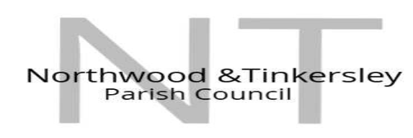
Clerk-RFO & Proper Officer: Steven Tomlinson
Phone 07460434310 Email: clerk@northwoodandtinkersleyparishcouncil.gov.uk
Draft minutes
Council minutes for
26th November 2025

1) Apologies For Absence: None Received.
2) Social Media:
The Clerk recorded the meeting for the purpose of minutes accuracy.
3) Declaration of Interest: None Received.
4) Variation of Order of Business: None.
5) Public Participation:
- Members of The Public: Mr and Mrs Goodwin discussed planning application 25/00960/FUL. They explained why they wanted to do with the building in question.
Mr Barry Mellor Discussed the footpath around the forest and quarry. He told council that all though he had tried to talk to Derbyshire County Council he had received no communications, He also talked about concerns regarding the Victorian pipeline near the quarry.
- Local Authority:
Councillor Roger Shelley from Derbyshire Dales District Council updated the Parish Council on the position they have taken on the Council devolution. He informed the Parish that they were backing proposal 1 which is to split Derbyshire into 2 authorities.
Councillor Shelley also informed Council that the local plan must be registered by the December 2026.
Councillor Susan Hobson from Derbyshire County Council. Informed us that they wanted to keep Derbyshire whole except for Derby City who are already a Unitary Council.
Councillor Hobson also spoke about winter highways plans including Gritting and Road clearing and agreed to keep Council up to date.
Councillor Hobson also advised us on some funding that is available. That the council will look in to.

6) To approve minutes: Approved unanimously.
7) Planning Applications:
A late application was received and added to the agenda with full consent of the Council. 25/00960/FUL. Council have agreed to meet with the owners and a committee comprising 3 councillors and 1 member of the public will visit the site at an arranged time and date.
8) To consider motions by councillors:
- Council agreed to have ID cards made and that councillors would go around the parish and gather information to add to the Parish database for mailing lists.
- Councillor Lindebaum was thanked for her quick work on having the play horse repaired. Council also agrees to send a thank you letter to Emma Mortimer for her quick actions in having the work completed.
9) Recreation Ground Update:
Council spoke at length about the offer of a Lease rather than a Cultivation Licence. Councillor’s Wragg and Neath to work with the Clerk when we receive the proposal of the lease. Also to arrange a face-to-face meeting with Derbyshire Dales District Council.
10) Draft Budget:
Council agreed the draft budget unanimously. Cllr Ragg asked for a breakdown of training costs to help bolster the budget and so that the public can see where their money is being spent.
11) Audit:
Council agrees unanimously to moving our Auditor to Derbyshire Association of Local Councils (DALC)
12) Council Meetings:
Council agrees unanimously to move the council meeting to a Tuesday night commencing Tuesday 20 January 2026
13) Items in Isolation:
Council agreed unanimously to take item 14 into isolation given the sensitive nature of the report.
14) Next Meeting Date:
The next meeting Date will be at 7:30pm on Tuesday the 20^{th of} January 2026

Signed by the Chairman on behalf of the Parish Council.

