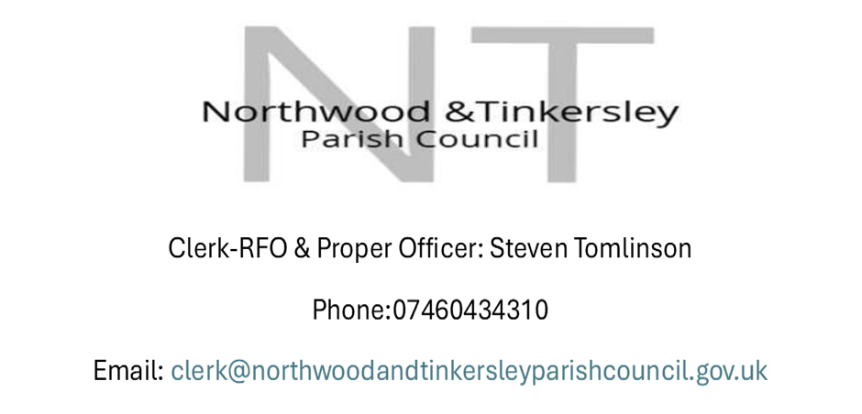
Council Meeting Summons
Yoar are here by summond to attend the Ordinary Meeting of
Northwood and Tinkersley Parish Council
Tuesday 22cnd of September 2026 at 7:30pm
Rowsley Village Hall, School Lane, Rowsley DE4 2EE
For the purpose of transacting the business on the agenda.

Steven Tomlinson.
Clerk-RFO & Proper Officer.
NORTHWOOD & TINKERSLEY PARISH COUNCIL.

Dated: 15th of September 2026
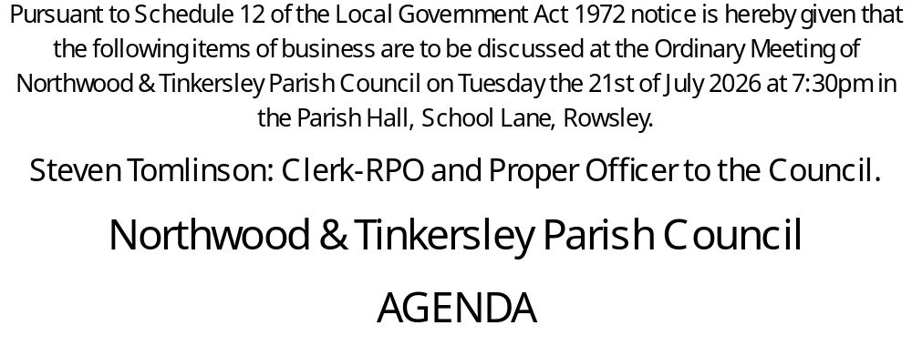
- Apologies for Absence:
- Social Media: The Council welcomes the use of social media, filming and recording at meetings, provided that such activities do not disrupt and or otherwise have an adverse effect on the meeting. Members of the public wishing to record the meeting should declare so at this point.
- Declarations of Interest:
a) Declarations of Members Interests
Members of the Authority are required to declare any interests they have which are covered by Section43 of the Localism Act 2011.

(b) Register of Members Interest: As a matter of good convenience and best practice, members are reminded that they have a duty to keep their register of interest up to date, and that any changes in their interests should be declared to the monitoring officer of Derbyshire Dales District Council within 30 days of the member becoming aware of the change.
- Variation of order of Business:
- Public Participation:
- Members of the Public:
In accordance with Standing Orders members of the public will be given a total period of thirty minutes (each member of the public is entitled to speak for a total period of five minutes) in order to ask questions on matters stated on the meeting's agenda.
- Local Authority Section:
If the Police Liaison Officer, a County Council or District Council Member is in attendance they will be given the opportunity to raise any relevant matter.
- To approve the minutes for the ordinary meeting held on 21st of July 2026:
- To Approve any item to be taken into exclusion:
The Clerk recommends that Item 70.26/27 be taken into isolation as it is a staffing issue.
- Finances: Expenses and income since 21st of July 2026
- Clerks Wage £ 653.20
- Rowsley Room Hire £60.00
- Parish online £430:00
- Gallagher Insurance £438,55
- Nbb Recycled furniture £1440.00
- Nbb Recycled waste bin £ 572.99
- Assembly and fixing cost £400.00
- Delivery cost: £45,00
- SLCC/NALC Membership/ OCI membership £974.99
- Travel Expenses £79.20
- Clerk expenses £172.43
- Lease Bill £179.00
Main Account £4435.04 Reserve Account £5684.73

- Planning Applications: 26/00808/FUL, North Park Farm, Whitworth Road,
Darley Dale DE4 2HJ. Council instructed the Clerk to Object to this planning application, due to the size of the building and other concerns. Council are to resolve that this is still the case and that they are happy that this decision was made Via email conformation prior to this meeting.
- Clerks Job Evaluation: For Council to evaluate the work of the clerk and to discuss the clerk hourly rate: Appendix A Confidential
- Correspondence: To discuss any important correspondence received after the agenda has been issued and has been forwarded to all Councillors.
- Councillor Items: To discuss items proposed by councillors: None Received
- Date of Next Meeting

